**Sample Leet Code Submissions**

****Two Sum** – Problem #1**

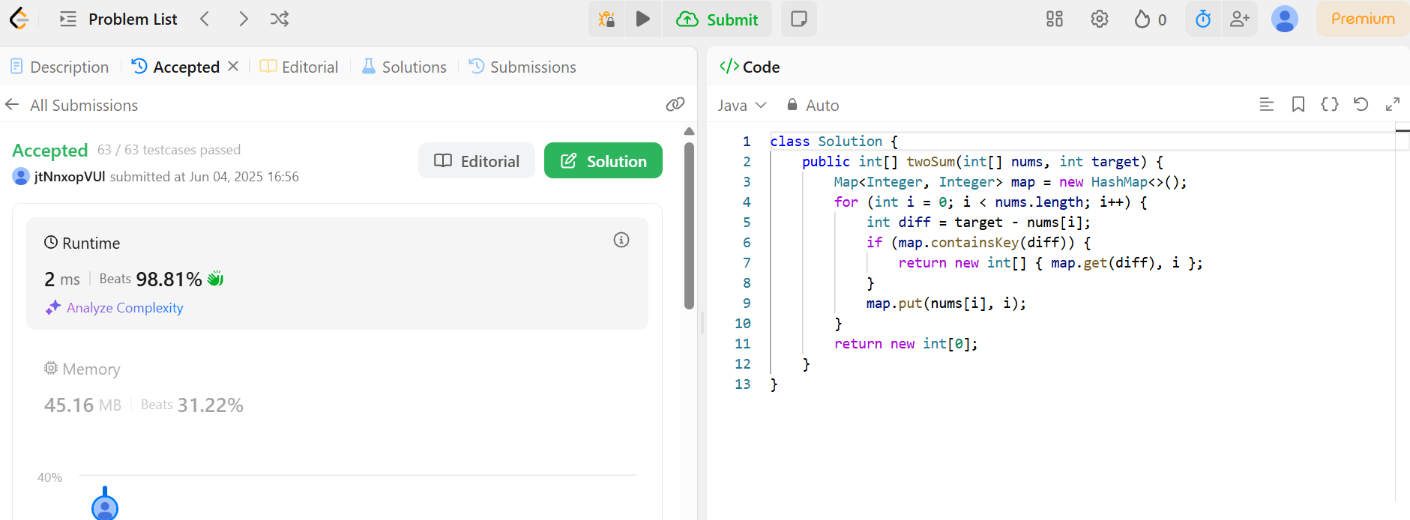

**Palindrome Number** – Problem #9

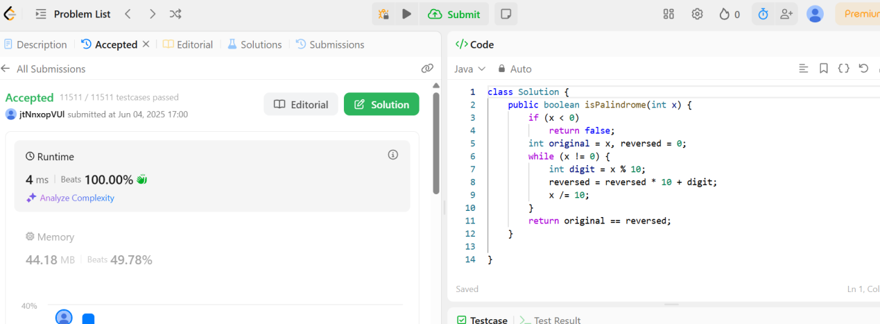

**Valid Parentheses** – Problem #20

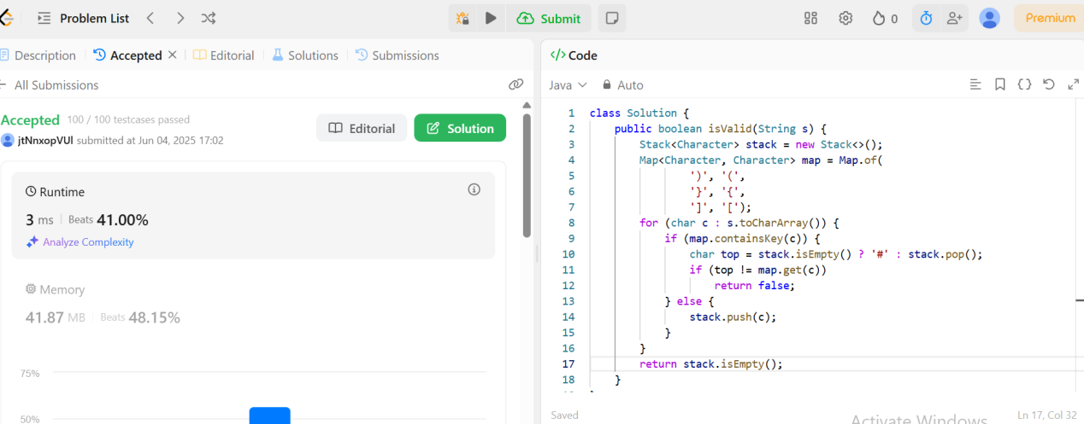

**Merge Two Sorted Lists** – Problem #21

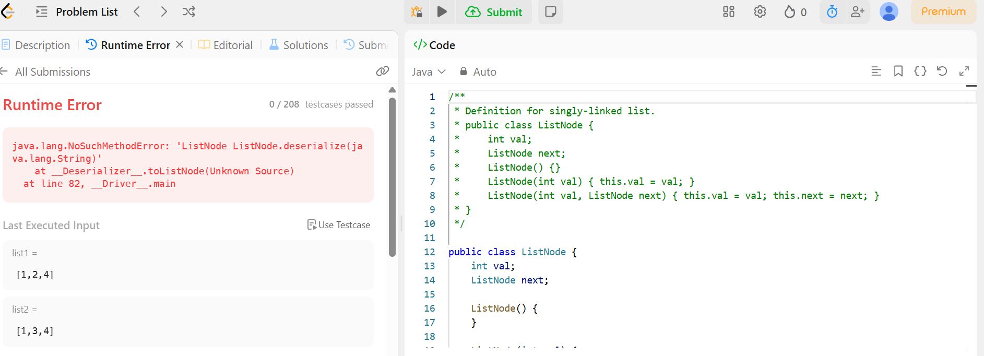

===============================================================================================

**Mail your submissions in a Word document as given above to Michael Samuel and Stephen.Samuels@apexon.com**